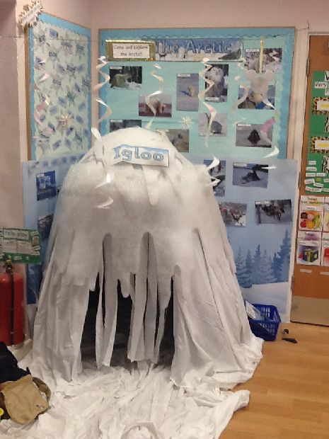
Winter Wonderland
Age Level: Pre-K
Subject(s) Area: Approaches to Play and Learning, Physical Development, Language Arts, and Math
Materials Needed:
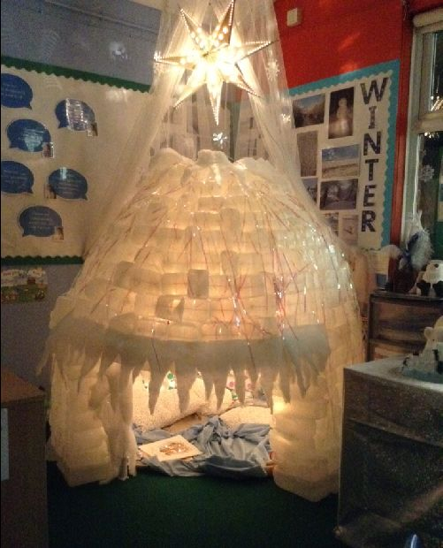
- Empty milk cartons to make the igloo – with a sheer white veil over the top
- Different cold animals that life in Antarctica – picture and name and place on a bulletin board
- Pillows and blankets to fill the inside
- Cotton in pieces with a shovel – students practicing real life skills of shoveling pretend snow
- Tennis rackets with scraps to show students how to walk with ever snow
- A lamp to keep the igloo lit
- Scooping snow balls – using a tweezers to move a cotton ball from one jar to the next
- Bring in real snow for the sensory table
- Do you want to build a snowman – cover boxes with white paper and let students build a snowman by stacking the larger, middle, and littlest on top – complete with paper buttons, eyes, nose, mouth and hat

Standards: (K-3 or Pre-K Content Standard OR Early Learning Guidelines)
APL.1.2 Sustain attention, interest, and focus on activities and engagement with experiences
PD.1.5 Use eye-hand coordination to complete task – the cotton ball movement
LL.1.5 Understand that illustrations and pictures convey meaning – using the igloo as a reading tent
MTH.3.3 Order objects by size and length – this is building the box snowman
Objectives: Students will:
Students will sustain attention and interest with the winter wonderful materials
Students will use eye-hand coordination to move the cotton balls.
Students will picture through books and understand the illustrations have meaning – within the igloo
Students will order the snowman box from largest to smallest to build a snowman
Learning Activities:
Set up Winter Wonderful before students arrive
Collect snow and put in freezer before placing it into the sensory table
Tell students about winter while asking reflective questions – seeing what they know about winter
Go over the materials brought to class and how they connect with winter:
- Empty milk cartons to make the igloo – with a sheer white veil over the top
- Different cold animals that life in Antarctica – picture and name and place on a bulletin board
- Pillows and blankets to fill the inside
- Cotton in pieces with a shovel – students practicing real life skills of shoveling pretend snow
- Tennis rackets with scraps to show students how to walk with ever snow
- A lamp to keep the igloo lit
- Scooping snow balls – using a tweezers to move a cotton ball from one jar to the next
- Bring in real snow for the sensory table
- Do you want to build a snowman – cover boxes with white paper and let students build a snowman by stacking the larger, middle, and littlest on top – complete with paper buttons, eyes, nose, mouth and hat

Reflective Questions:
What is winter?
Is winter usually cold or hot?
Where does winter take place?
When you think of the winter, what are some descriptive words that you think of?
What do you imaging winter looking like? Feel like?
How do you feel when reading inside the igloo?
What is the hardest thing about shoveling the pretend snow?
Why do you think the snow melts so fast in our classroom?
What would happen if we build the snowman from smallest to largest on top?
Vocabulary Words:
Winter Wonderland
Antarctica
Names of animals placed on the bulletin board
Shoveling
Assessment:
Based on your Standards and Outcomes of the activity you are using the space for.

Reflection:

