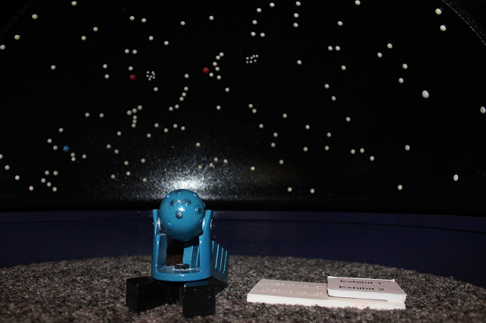
Starlab Language Arts Lesson
Grade: First and Second Grade

Subject: Language Arts

Materials:
- Starlab dome with star night cylinder
- Worksheet (attached)
- Pencils
- Black construction paper
- Glue sticks
- stapler
- Table Constellation groups
- Constellations Myths and pictures (attached)
- Tape for the table names

Standards
- First Grade Standards:
  - W.3 Write narratives in which they recount two or more appropriately sequenced events, include some details regarding what happened, use temporal words to signal event order, and event, order, and provide some sense of closure
- Second Grade Standards:
  - W.3 Write narratives in which they recount a well-elaborated event or short sequence of events, include details to describe actions, thoughts, and feelings, use temporal words to signal event order, and provide a sense of closure.
Objectives
- Students will participate in the dome and myth reading
- Students will be able to create their own constellation myth
- Students will have the knowledge of what constellations are
- Students will write using descriptive wording, ordered sequence, and use correct punctuation and spelling.
Learning Activities
- Preparation before:
  - Set up dome
  - Get chords and fan lined up
  - Check lightbulb in projector
  - Get fan up and dome blown up
  - Have all materials in the gym:
    - Writing worksheet on Constellations
    - Students should have pencils and glue sticks
    - Have construction paper set out
    - Glue
    - Table Constellation groups
    - Stapler
    - Myths and pictures of the constellations in the dome
- REMIND STUDENTS THEY MUST BE QUIET (echoing) With the light on in the dome, have students make their way inside
  - Tell students it will be a little squishy but we need to all fit
- Reflective Questions
  - Does anyone know what constellations are?
  - What makes up constellations?
  - When can you see constellations?
  - Do you know of any constellations?
- Turn main light off and switch on projector
  - Remind students their eyes might take awhile to adjust to see the stars
- First point out the the little dipper. Also known as The Little Bear
- Ask students if they know what a myth is.
  - Myth- a traditional story usually involving people or supernatural beings such as bigfoot from the past
  - Read the small myth that goes with it
  - Ask students if the myth matches the picture they see of the constellation
- Point at the constellation of The Greater Dog also known as Canis Major
  - Ask students if they like hunting or dogs (raise hand) - which leads into the myth of The Greater Dog
  - Read the myth that goes along with The Greater Dog
  - Point out The Lesser Dog that goes along with the myth
- Point out Draco (The Dragon) constellation
  - Read the myth that goes with that
  - Turn light on again
  - Show class the pictures of Cadmus fighting the dragon and how the stars form the shape of the dragon
- Tell students that now we are going into the cafeteria and will be drawing and writing our own constellations in groups
- Have students slowly exit the dome
- Take all students into the cafeteria
- Tell what students are sitting at which constellation table
- After students are in groups and sitting by their worksheet and construction paper go over directions of the worksheet
  - Write both names on the worksheet
  - Come up with a constellation name
  - Draw your constellation
  - Go over items to include in your constellation myth/narrative
    - Must tell how the constellation represents the myth
    - Beginning, middle, and end to story
    - Descriptive wording
    - Punctuation and correct spelling
- Let students finish their myth worksheet and check with teachers
- Then their last step is to glue the sheets onto the construction paper
Assessment
- Rubric for Star Constellation Narrative Writing 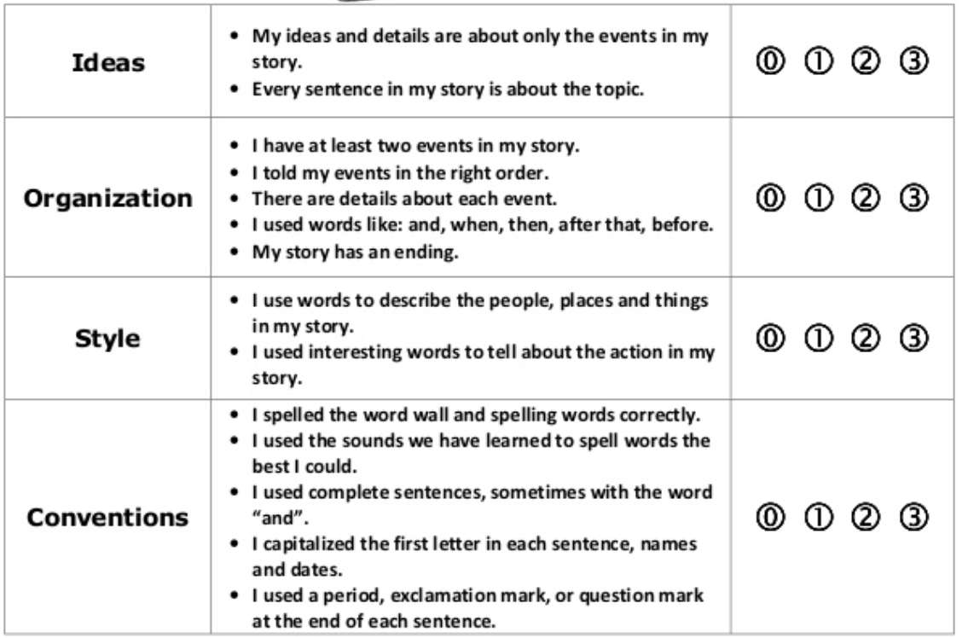
Reflection
- Entering the students into the new environment, I wanted to be very proactive.
- So setting after setting up - myself, as the teacher, went through the simulation to think in the eyes of the students what it would be like to witness this.
- With my practicum 2nd graders – I filled them in with the Star Lab dome, things I told them in the morning meeting was:
  - The Star lab is a big dome
  - To get inside you have to crawl
  - Some stars are going to project onto the circle ceiling of the dome
  - Once the projector is on – it will be completely dark on the inside
  - I also kept telling the 2nd graders that be a good example to the 1st graders because you are the older class and should be good models for the younger class
- Once Kylee and I got both the 1st and 2nd graders down into the gym before entering the Star Lab – I again kept saying that the inside of the dome is going to be completely dark once the projector is on
  - That is echoing that will carry – I did an example of what an echo was
  - Even a whisper – so staying at a zone 5 during the dome is very important
- Going into the dome – Kylee went in first with one of her students that needed to be supervised
- And I stayed outside calling the quite 1st and 2nd graders in first – I kept saying “Oh I love how Little Johnny is sitting quietly, he may go into the dome”
- Once all students and teachers were inside – Kylee and I started asking prior knowledge of stars
  - What is a star?
  - What is a group of stars called?
- After we told the students that inside our new environment we are going to be looking at the stars and reading stories about them
- Kylee read one story after pointing at that constellation and then read the 2nd story after pointing out that constellation
  - Remind you it was almost pitch black in this dome, and we were using the phone flashlight covered up by our hands – so there was barely ANY light
- So I decide to think of my toes and switch up the lesson a bit
- Instead of reading the last story – we asked one 1st grader and one 2nd grader to stand up and point out a constellation that they knew or about a figure of stars that looked like something to them
  - This was better because in this environment it gave the students the ability to think freely and share what their thoughts were in this new environment
- After about 15 minutes in the dome – I came back out and told students once they were coming out to sit down
  - Waiting for all the students to come out so we could travel to the lunch room together – I asked the ones who were sitting down already what there favorite constellation in the dome was
- Traveling into the lunch room I told my 2nd graders where to sit and Kylee told her 1st graders to sit beside for the partner
  - We had the table names, papers with group names, and materials set out already
- Because this was a new environment for learning – we wanted things set up and in order so students know what to expect and where to go
- After groups were all sitting we told them that the activity was create their own star, own star name, and their own story about the star
- Once they started writing Kylee and I kept walking around helping form ideas and formulating thinking about star stories
- I noticed that we both were very good at getting down at their levels – the students are sitting and if we were hovering over them wouldn’t be as affective because we aren’t showing that we are in the same environment they are
  - Getting down to their level helps them know we are part of their team too – that we are there to help and to be a teammate with them too

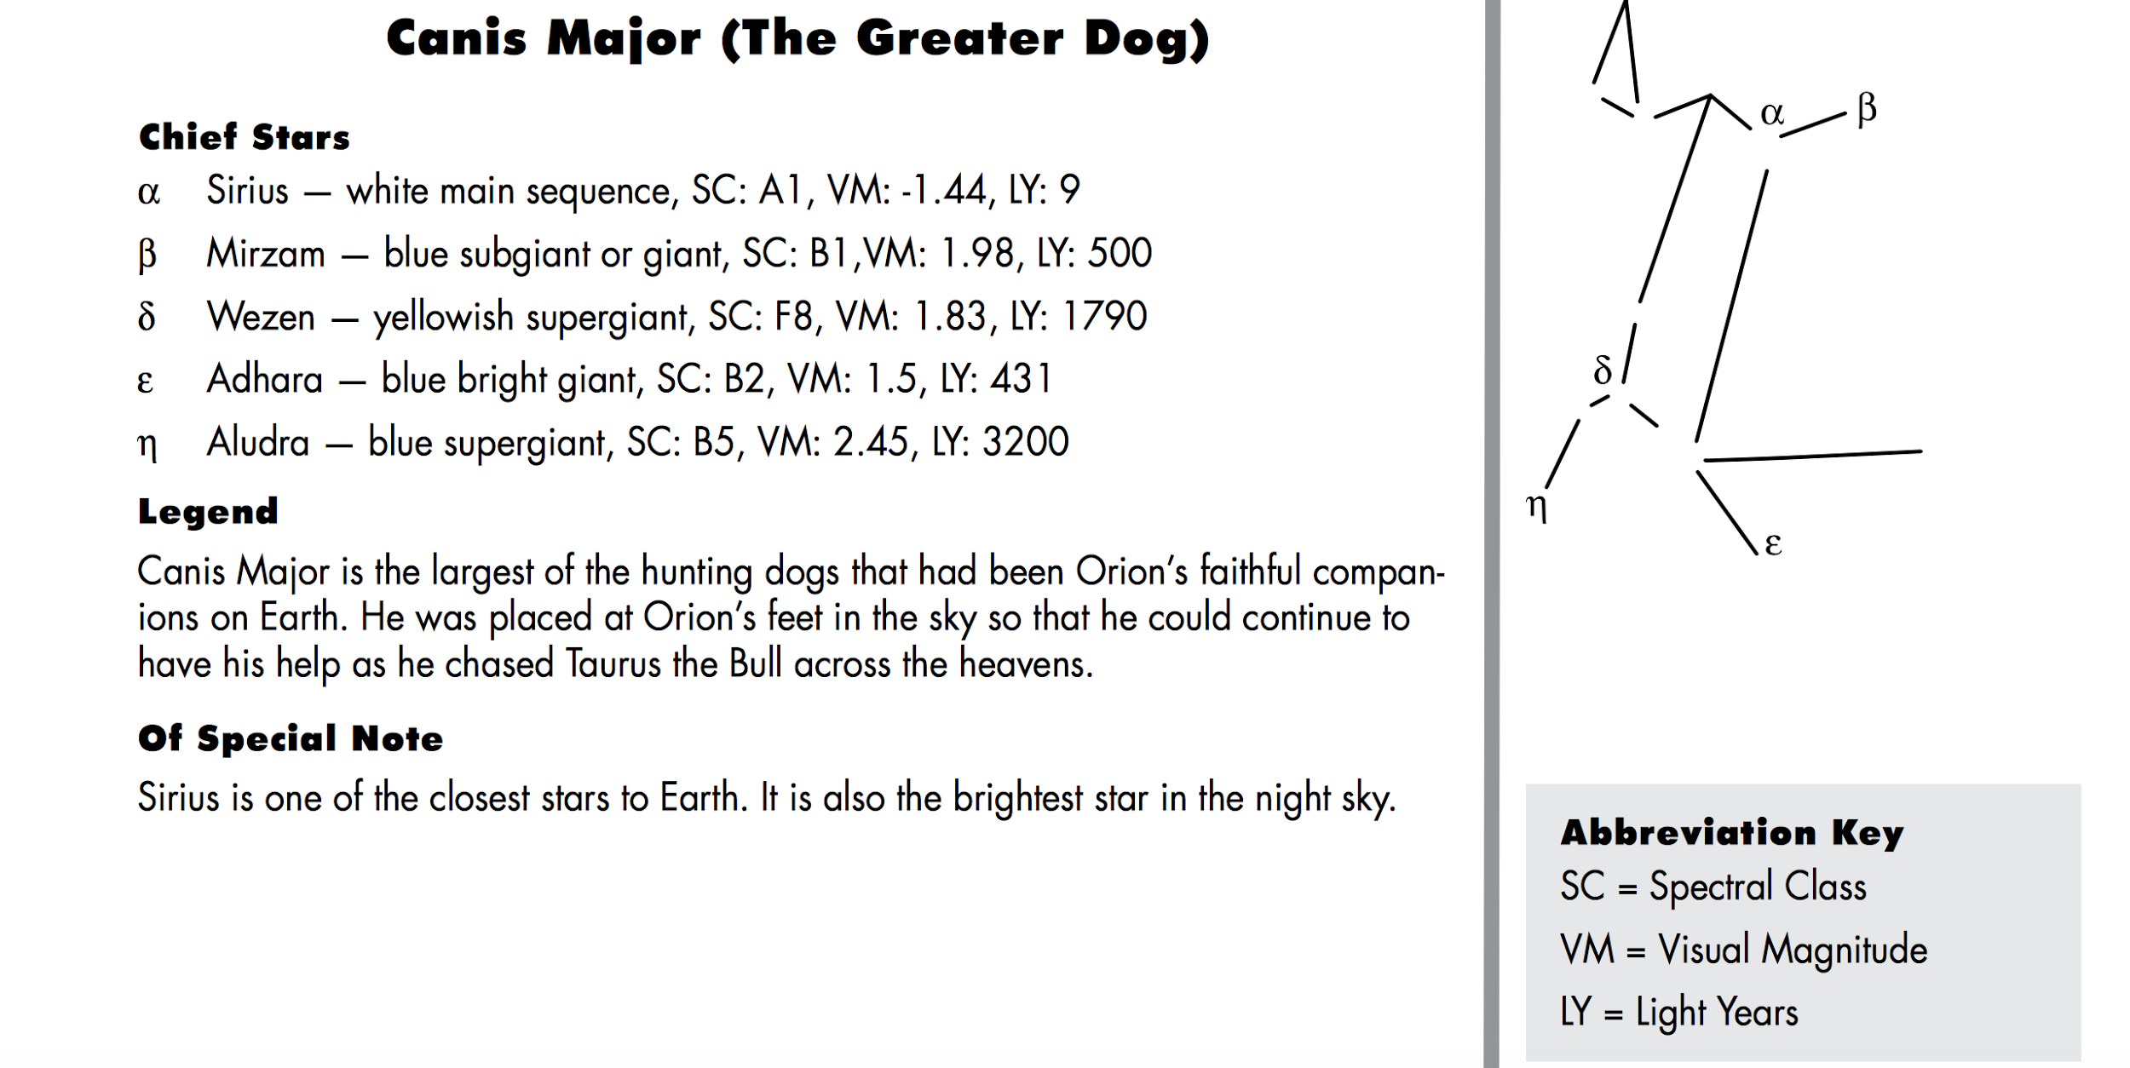
Canis Major - The Great Dog
Every hunter needs hunting dogs as companions and the Great Hunter Orion is no exception. Orion has two dogs as companions, Canis Major (the Great Dog) and Canis Minor (the lesser dog). Both of these faithful companions sit at the feet of Orion waiting for their next expedition.
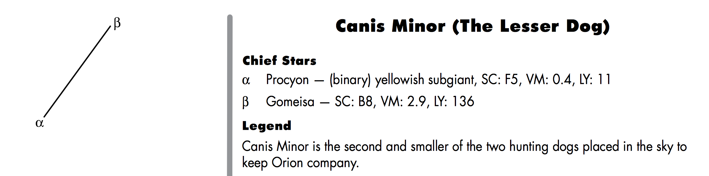
In addition to being one of the companions of Orion, Canis Major is also the stellar home of Sirius, which is the brightest star in the night sky. When Canis Major is visible, the brilliant white light of Sirius shines like a searchlight in the sky. Although Sirius is not a very large star, being only about one and one-half times as large as our own Sun, its young age and relatively close distance combine to make it so bright.
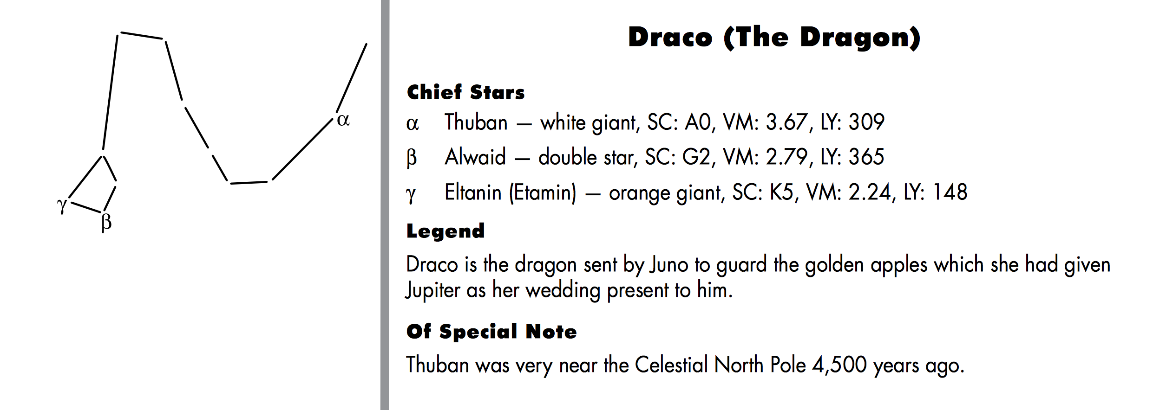
According to this story, Zeus had stolen the young woman from her home country. Her father ordered her brother, Cadmus, to go and search for her, and not return until he had found her and brought her back with him.

The brother, Cadmus, wandered over the whole world looking for his sister, but could not find her. He knew he would never find her because no one can find someone that Zeus has hidden. After not being able to find his sister, he wanted to build his own city.

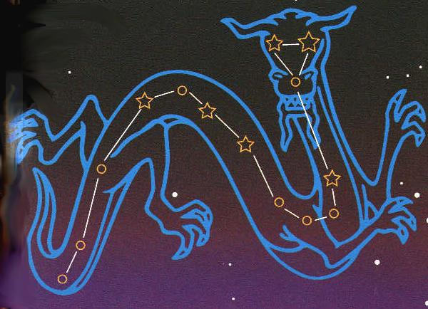
While searching for water some of the brother’s friends were killed by a large dragon. Cadmus went to fight this dragon, and upon finding the dragon in a cave, was able to kill it with his spear. Cadmus was told to plant the dragon’s teeth in the ground.
Because Draco had been so faithful in guarding the caves and the teeth in the ground, Zeus placed his constellation in the northern sky, where, because his constellation never sets, he can guard all the treasures.
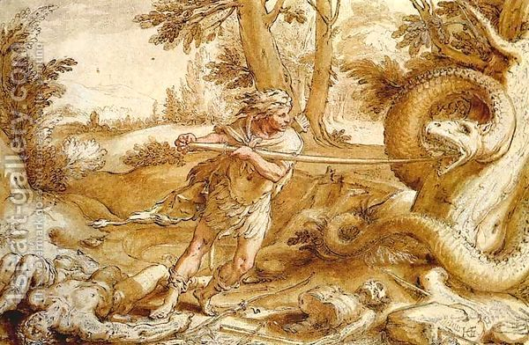

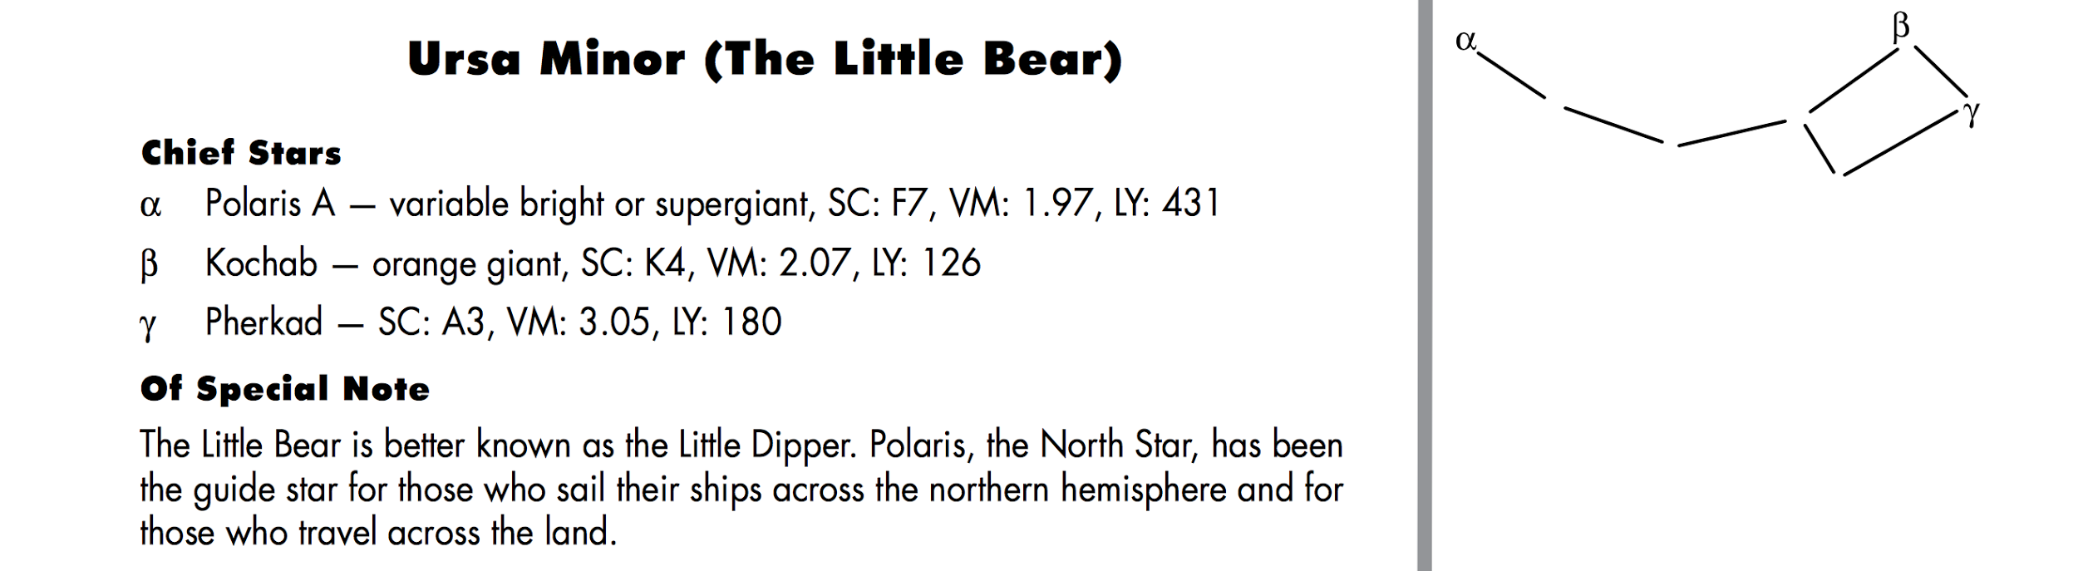

Constellation Partners
First Grade Second Grade
Jaymeson Conner
Chloe Rebecca
Caleb Ali
Bailee Ethan
Leticia Carter
Rayden Norah
Zaveyah Garrett
Hudson Mason
Titan/Kaliah Elliot
James G. Elizabeth
AShton Anna
Kristofer Cadence
Hassan Noah
Bella Bailey
Breanna Chastyn
Brady Jasmine
Gavin Kayla
James W. Justin

Create a Constellation
Names___________________________
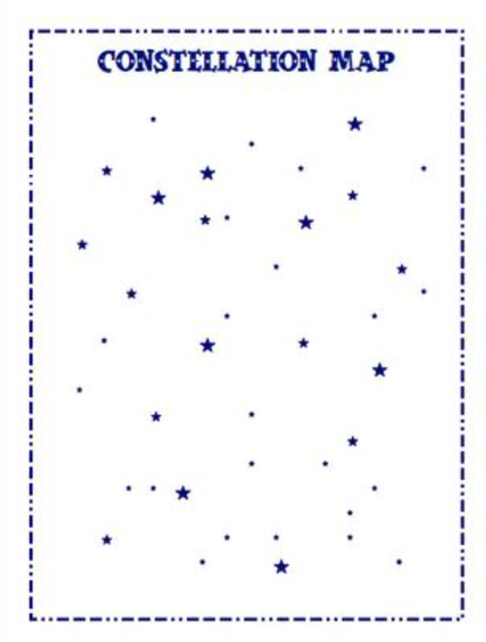
Name Your Constellation ________________________________________

The myth of my constellation:
**Remember to include:
- Must tell how the constellation represents the myth
- Beginning, middle, and end to story
- Descriptive wording
- Punctuation and correct spelling

_______________________________________________________________

_______________________________________________________________

_______________________________________________________________

_______________________________________________________________

_______________________________________________________________

_______________________________________________________________

_______________________________________________________________

_______________________________________________________________

_______________________________________________________________

_______________________________________________________________

_______________________________________________________________

The Dragon Table

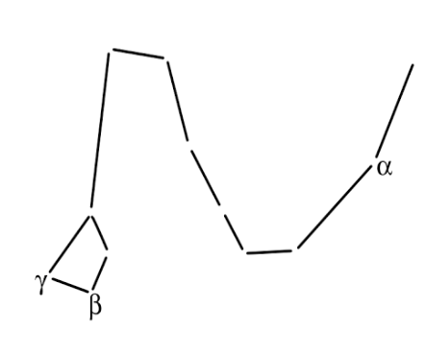

The Little Bear Table

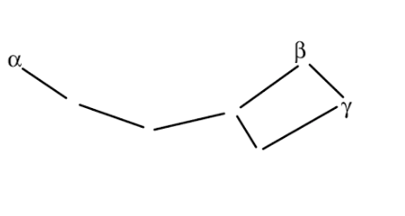

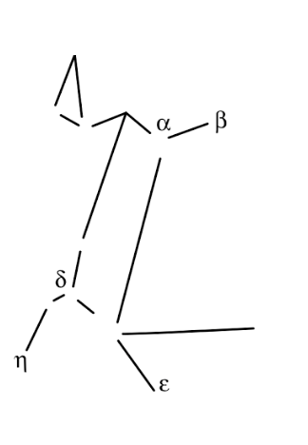
The Greater Dog Table

