Let’s Paint Salt

Age Level: Toddler - 2 year old
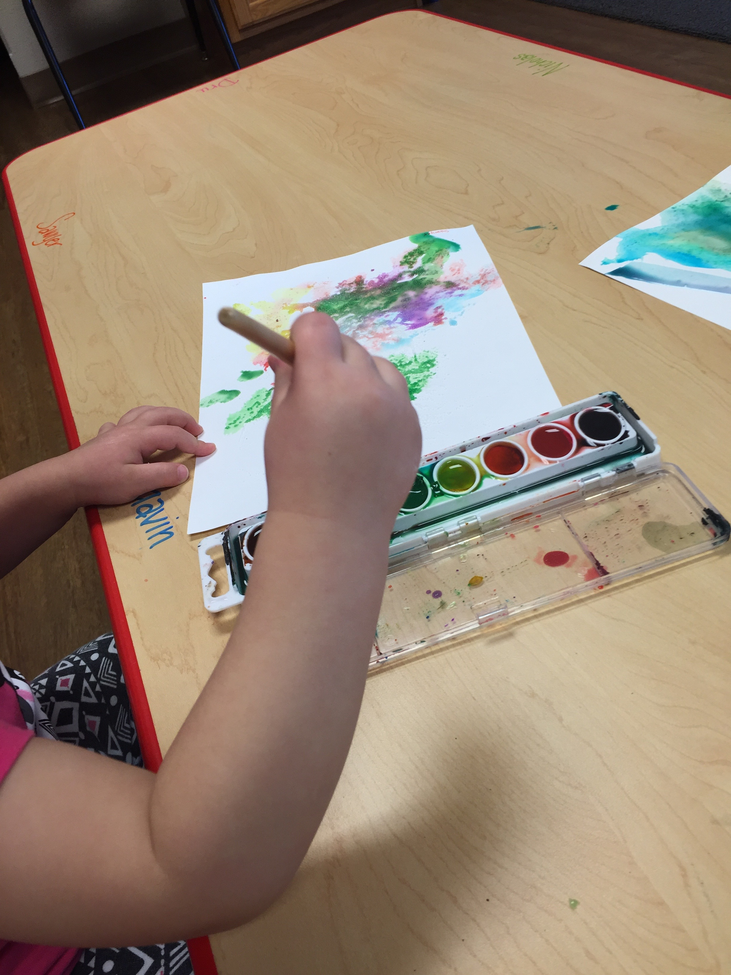
Subject(s) Area: Fine Motors and Art
Materials Needed:
- Thicker white paper
- Paint brushes
- Watercolor pallet or tube paints
- Elmer’s liquid glue
- Paper plates
- Q-tips

Standards: (Pre-K or Kindergarten Standards or Early Learning Guidelines)
- Developmental Fine Motors
  - Hand-eye coordination
  - Develop small muscle control

Objectives:
- Child will be able use hand-eye paint overtop of the salt
- Child will discovery color mixture when placing one paint over another color

Learning Activities:
- This activity will work with only 2 or 3 children at a time so I am watching their motor skills and making sure now paint, salt, or glue is going into the mouth
- First take a piece of paper and allow child to place glue on the paper with Q tips
- Right after the glue – I place the salt on top so it dries to it
- After waiting a few hours, let the child paint over the salt and glue mixture
- Discovering what will happen with the paint when it hits the salt pieces

Also include: Reflective Questions and Vocabulary Words introduced
- Reflective Questions:
  - What happens when there is more salt on the paper?
  - What does the ____ and ____ make when we mix the paints?
  - Can you show me how to get paint on top of this glue and salt pile?
- Vocabulary Words:
  - Different Color Names
  - Mixture
  - Cover
  - Pile
  - Salt
  - Paint

Assessment:
- Observing while they discover the hand-eye coordination of painting
- Looking at their painting at the end making sure they were able to cover over the smooth and bumpy salt surfaces

Reflection:
Did the whole group work?
- I did the whole class – but I pulled them in smaller groups of 2 and 3 students
- That was kind of hard because the students who haven’t gone yet were just sitting and waiting because they were very anxious to try their turn
Where the children engaged?
- The children’s hand-motor skills were complete engaged – they hands had to practice dipping their brushes in the paint – and move it around on the paper (I would also ask them while they were painting if they could cover a certain spot)
- They also loved seeing how the salt would move with the glue and make the clumpy
What was hard for the students or hard for the students to grab the fine motor concept?
- The students were able to practice their motor skills
- This concept was not hard for the students because they were able to use their paint brushes to paint the picture over the salt
- They also were able to use the Q-tin to on the glue and place the glue on the paper

