Reading Tent

Age Level: Pre-K
Subject(s) Area: Social and Emotional Development, Approaches to Play and Learning, and Language Arts
Materials Needed: This tent would fit very well in Miss Lacey’s Montessori Classroom – that is why I choose this idea
Her reading corner is in a perfect spot with the wall space to help
Whatever colors clothe
Tacks (if not nails) to hold up
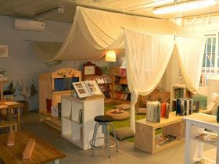

Standards: (K-3 or Pre-K Content Standard OR Early Learning Guidelines)
SED.2.7 Work cooperatively with others and exhibit appropriate social behavior
APL.1.4 Filter out and ignore most distractions and interruptions
LL.15 Understand that illustrations and pictures convey meaning
LL.1.6 Know that reading is valuable and enjoyable

Objectives: Students will:
Students will work cooperatively with others inside the tent
Students will exhibit appropriate social behavior in order to stay in the tent – which is a privilege
Students will filter out other distractions when inside the tent – their job is to be look at books
Students will understand that pictures are telling a story
Students will have a better understanding inside the tent that allows them to know reading is valuable and enjoyable
Learning Activities:
Gather students around the set up tent
Let them know that reading tents are to help engulf you in the world of reading
Help them feel like they are in a different room – their own world while reading – letting the book become part of their mind
Reflective Questions:
What is a tents main purpose outside?
What is the difference with the purpose of this tent?
How does seeing the tent make you feel? Does it make you want to grab a book and read?
Vocabulary Words:
Their own world
Privilege
Filter
Distractions
Understand
Valuable
Assessment:
Based on your Standards and Outcomes of the activity you are using the space for.

Reflection:

