2nd Grade Olympics

Grade Level: 6nd

Subject(s) Area: Physical Education
Social Studies

Materials Needed:
- Promethium Board to watch (4 minutes) http://www.watchknowlearn.org/Video.aspx?VideoID=50663&CategoryID=4184
- White board to draw a time line
- Sheets of import events to place on timeline (attached)
- Pre-made Olympic Torch – Tin foil wrapped around empty paper towel role with red and yellow tissue paper flames)
- Ring Toss – 3-5 rings and a bottle or cylinder to hook the rings on
- Olympic Balance Beam – Tape placed on the ground for students to balance
- Balloon Badminton – Two paper plates taped onto two different pop sickle sticks; a blown up balloon
- Cotton Ball Shot Put – place tape on the ground; place a bowl full of cotton balls beside it
- Olympic Stack the Cups – 25 (or so) plastic cups
- Cross Country Skiing – 4 long paper cut skis
- There it blows – 2 plastic cups and number of student straws
- Olympic Coloring – page attached: print out correct number of students
Standards:
Physical Education:
- S1.M2.6 – throwing
- S1.M10.6 – shooting into a goal
- S2.M1.6 – creating and reducing space with movement
- S2.M6.6 – transitions
- S3.M6.6 – fitness knowledge

Social Studies:
- 6.2.9 Identify the features (e.g., early democratic government, Olympics) and accomplishments of classical Greek civilization (e.g., contributions to art, literature, science, and philosophy; the development of the concepts of citizenship)
Objectives:
- To see if students can grasp information from the Olympic Video to work as a class to fill in the timeline
- Get an understanding of how Olympic games came into current times by building a timeline
- Being able to relate the history of the Olympics into their life by participating in the classroom games
- Prior knowledge necessary is ability to engage in video and comprehend
- Prior knowledge for physical education is being able to have hand-eye coordination to participate in Olympic classroom games
- Teaching students in a kinesthetic way how to build a timeline
- Getting students to relate the information being taught into their own active movements
Learning Activities:
- While students are out of the room and/or working on things set up different games around the room
*Look back on materials needed; numbers 1-7 have the supplies and set up instructions
- Have promethium board and Watch Know Learn Olympic short video pulled up and ready to play
- Get students to come sit down in the circle area
- Give them a brief description about Olympics
*Asking them if they have ever heard of Olympics before
*Seeing if they know what the Olympics is about
*Ask some of their favorite events if they know what it is
Accommodations: Talk about winning and losing, being good sports, and how real Olympians react after competing with whole class
- Play the short video of Olympics
- After video draw an empty timeline on the board
*Tell students what a timeline does
*Let them know it helps organize events that happened in history
*Bring in Past and Future terms (Mrs. Jahner is working with them on this)
- Show them the sheets of important events throughout the Olympic timeline
- Work as a class together on placing the events in the right order on the board
*Using tape or a magnetic to attach the pictures to the drawn timeline
- Go over the Olympic Classroom Game Rules – pair students into pairs; each pair will be at a different game; each game will last 45 seconds to 1 minute (base on how students are playing); let students know if time isn’t over they can keep repeating their game until time is up
Accommodations: Pair student with another student who is mellow and easy going about situations. Inform that helper student about how being partners can be with Jeremy.
Let class as a whole and student by themselves individually know that each event is not a race or competition – it is just a way to get students informed to how Olympics are
*Olympic Torch: 2 students will take turns circling the room carrying the torch, once reached their partner they may pass it on
*Ring Toss: Set up bottle and allow 2 students to take turns tossing the rings onto the bottle
*Olympic Balance Beam: The tape marked on the floor is the balance beam they use to walk, hop, skip, and stand still practicing their balance
*Balloon Badminton: Each student during this rotation will have a paper pop sickle stick where they can pop the balloon in the air to each other
*Cotton Ball Shot Put: Students stand on the tape line and throw the cotton ball as far as they can, keep repeating to see how far they can actually throw (if students want to keep track of their distance – place a sticky note with their name where it landed)
*Olympic Stack the Cups – each student will have their own set of 4-3-2-1 cups and practice stacking the pyramid
*There it blows: Each student gets a new straw and blows the cotton balls from one end of the table to the other
*Olympic Coloring: Have a center where students will color the Olympic Rings
Accommodations: Let students know rules and consequences for being too loud, not participating, and overreacting to a situation if they win or lose – let them know what this is a fun activity and if student shows they cannot handle it, they will be asked to sit out for the remanding of the class just watching.

Work with student after that – giving him a sheet of green, yellow, and red. He starts on the green (good) and if he gets moved down to the red because of his behavior he will sit out.
- After all students have participated in events, have them sit back down in circle time to ask students which was their favorite game and hardest game

Assessment:
- Students will grasp information from video and apply it to building the timeline
- Students will understand the history of the Olympics
- Students will be attentive while watching the Olympic video
- Students will activity participate in building the Olympic history timeline
- Students will participate effectively in the classroom Olympic games
- Students will use prior knowledge on how to play the games
- Students will kinesthetically learn by participating in timeline building and applying knowledge to classroom games

Reflection:
- What did I do well?
- If I were to teach this lesson again, what would I keep the same?
- If I were to teach this lesson again, what would I change?
- This is completed after your lesson is taught.

The questions listed below each subheading are only guidelines when creating your lesson.

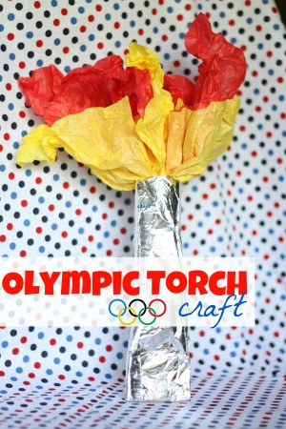
Example Ideas:
Good resource for this lesson in the future: http://www.icanteachmychild.com/olympic-activities-and-crafts-for-kids/?utm_content=buffer2fe53&utm_medium=social&utm_source=pinterest.com&utm_campaign=buffer

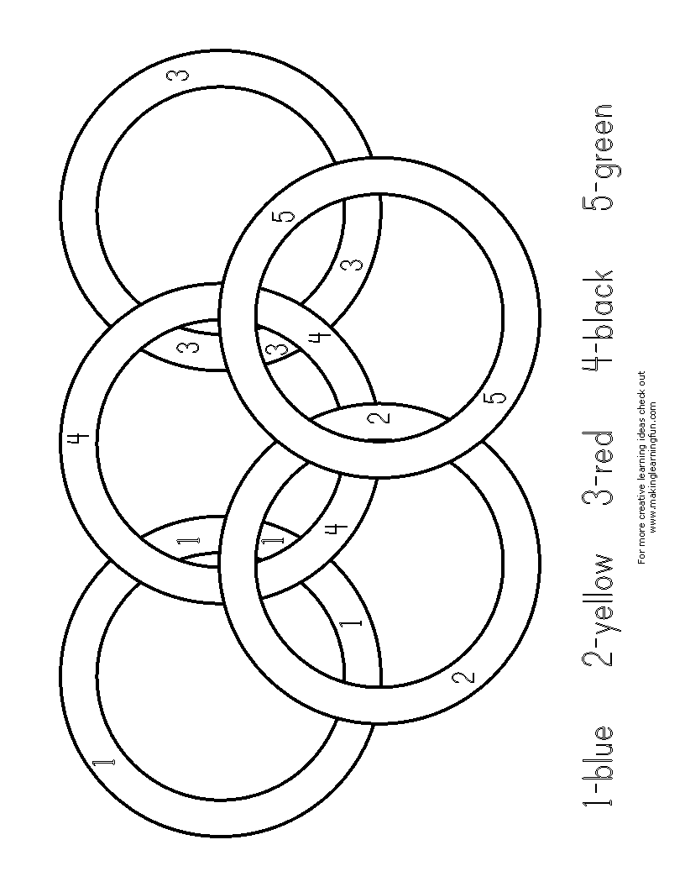
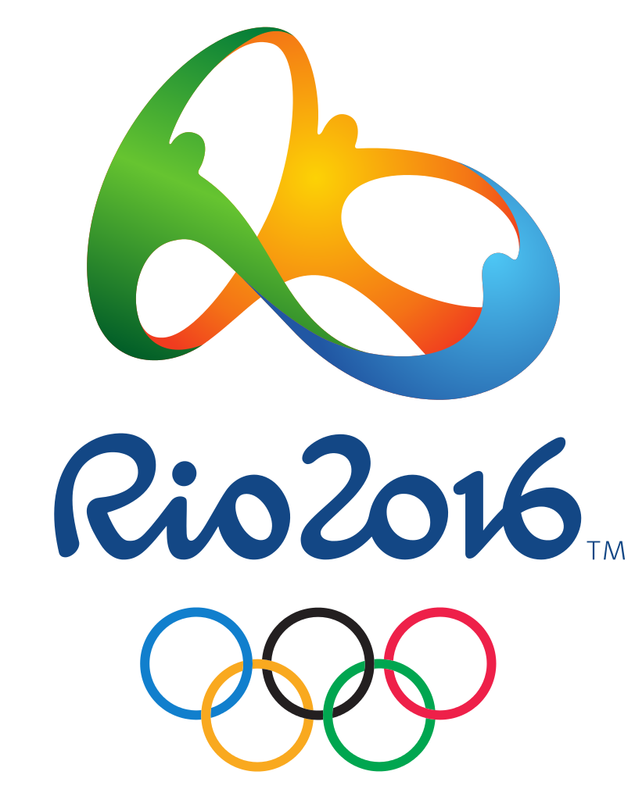

Next Olympic Games 2016

1924 First Winter Olympic Games
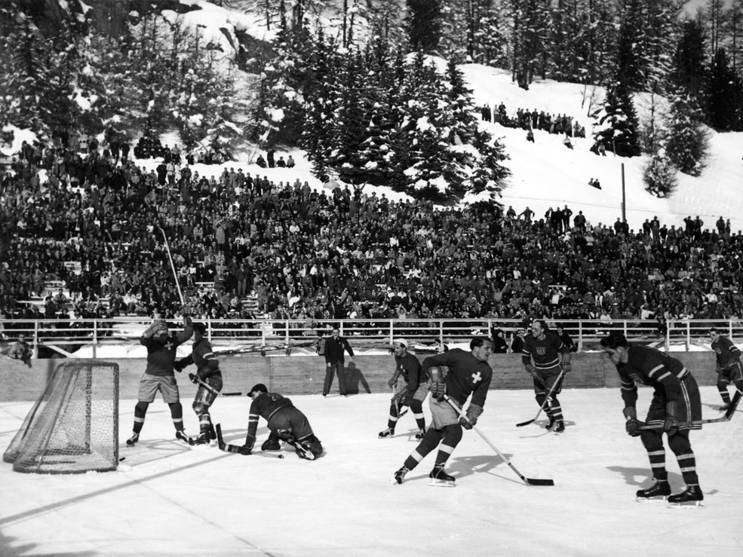

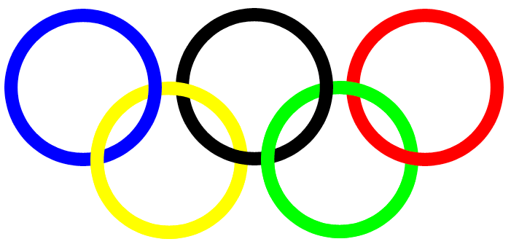
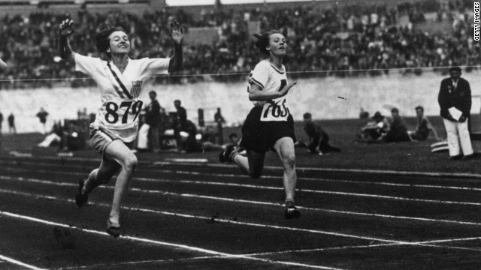
1914 Olympic Rings were created

1900 Women’s First Olympics

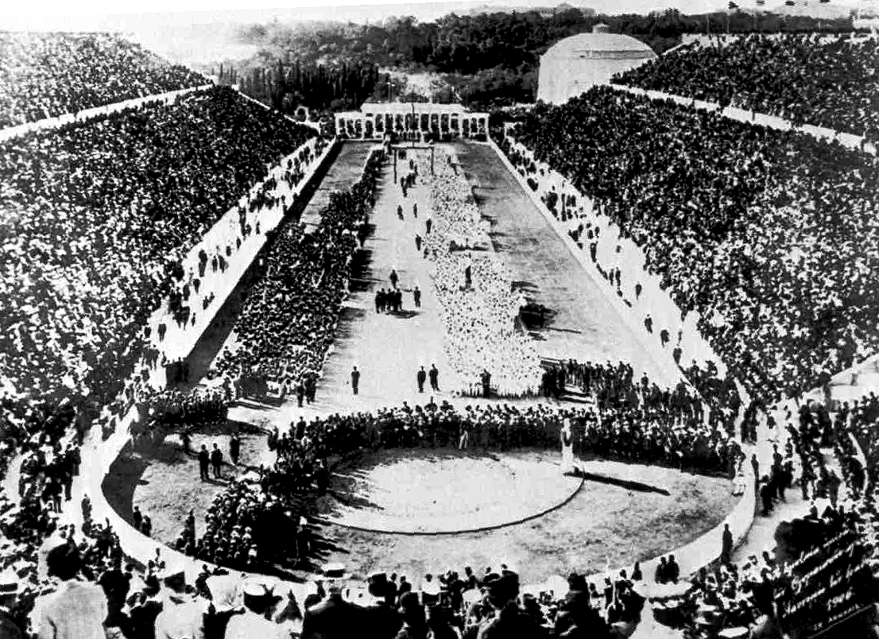
1896 First Modern Olympics

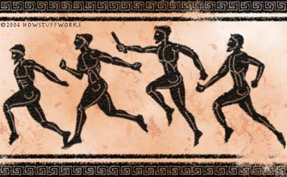

776 B.C. Greece Olympics

