Old McDonald Farm

Age Level: Montessori Pre-K

Subject(s) Area: Approaches to Play and Learning, Science, and Social Studies

Materials Needed:
- Wheelbarrow full of planting soil for students to explore hands-on and find fertilizer
- Cup Cake pan filled with different seeds in each up and then a picture of what the plant looks like when it grows
- Bring in stocks of corn (both green when growing and brown when ripe) to let students take apart and find the what is inside
- Place cream in a jar and let students figure out that when shaking it a whole bunch that butter forms
- Box full of garden ides: gardening gloves, trowels, watering can, flower pots, aprons, straw hats, and plastic vegetables
- Have a BIG box that is made into a red barn – inside the barn have real straw spread out on the floor
- Have a “Muddy Pigs” sensory table – fill up the tub with cornstarch, water, and brown paint to make pretend mud and place plastic pigs inside
- Have a farmers market that holds plastic vegetables and foods that farms grow that we buy
- “Let’s Go Farming” dress up box: straw hat, basketball caps, cowboy hats, blue jean bibs, winter coveralls, cowboy/cowgirl boots, water boots, work gloves, flannel t-shirts
- Have cardboard boxes stacked with straw and a paper chicken laying on it – have egg cartons beside the boxes that students have to feck the eggs from the “chicken coop”
- Bring in a square straw bale – drape a black over the back with a saddle – place a horse stick head coming out the top
- Have puppy, duck, chicken, cats, and etc. stuffed animals laying around the entire area

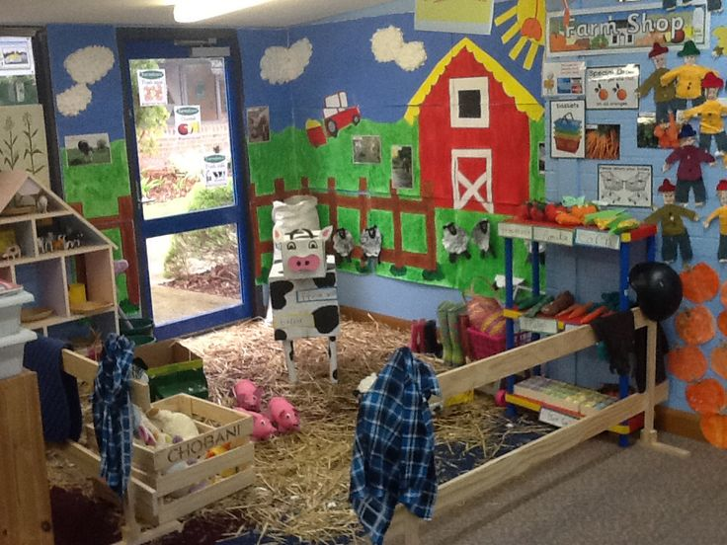

Standards: (K-3 or Pre-K Content Standard OR Early Learning Guidelines)
- APL.1.1 Show interest and eagerness in discovering and learning new things
- APL.2.5 Uses imagination to create a variety of ideas, role-plays, and fantasy situations
- SCI.1.2 Recognize and inquire about simple cause and effect relationships
- SCI.2.4 Make predictions and generate ideas based on past experience, observations, and information
- SS.3.1 Know that people perform various kinds of work to earn money to buy things they need
Objectives: Students will:
Students will be able to engage in discovering new things within farm center.
Students will use imagination to find out the process of each real material.
Students will inquire cause and effect relationships – rain makes good crops, pigs are hot roll in mud, and etc.
Students will make thoughtful predictions to think about how the material is used in real life.
Students will know that farming is a type of work that people do to earn money.

Learning Activities:
Depending on size of space – plan the layout that would be inviting and most learning based
Arrive and set up environment before students arrive
Once attention is on you and teacher allows you to talk – introduce the farm center
Ask students:
Does anyone know what a farm is?
Has anyone ever been on a farm, maybe your grandparents or uncles and aunts?
Does anyone know what farmer give to use that we use?
Just naming all of the different items that students can do in this center is enough – my main purpose for this is allowing students to figure out what each thing would be used for and use their imagination
Also to ask questions on their own – using their own curiosity to drive them
Go over the title and main idea of each…
- Wheelbarrow full of planting soil for students to explore hands-on and find fertilizer
- Cup Cake pan filled with different seeds in each up and then a picture of what the plant looks like when it grows
- Bring in stocks of corn (both green when growing and brown when ripe) to let students take apart and find the what is inside
- Place cream in a jar and let students figure out that when shaking it a whole bunch that butter forms
- Box full of garden ides: gardening gloves, trowels, watering can, flower pots, aprons, straw hats, and plastic vegetables
- Have a BIG box that is made into a red barn – inside the barn have real straw spread out on the floor
- Have a “Muddy Pigs” sensory table – fill up the tub with cornstarch, water, and brown paint to make pretend mud and place plastic pigs inside
- Have a farmers market that holds plastic vegetables and foods that farms grow that we buy
- “Let’s Go Farming” dress up box: straw hat, basketball caps, cowboy hats, blue jean bibs, winter coveralls, cowboy/cowgirl boots, water boots, work gloves, flannel t-shirts
- Have cardboard boxes stacked with straw and a paper chicken laying on it – have egg cartons beside the boxes that students have to feck the eggs from the “chicken coop”
- Bring in a square straw bale – drape a black over the back with a saddle – place a horse stick head coming out the top
- Have puppy, duck, chicken, cats, and etc. stuffed animals laying around the entire area

Reflective Questions:
What do you think soil feels like when it rains a whole bunch?
What would the seeds look like if it rained a lot during the growing time or if didn’t rain a lot?
What makes the corn stocks so thick in order to stand up so high?
Why do you think shaking the cream will form butter?
If you had your own farm, what would you place inside your barn?
If it is really hot during the summer, and you see pigs rolling around in the mud, why is that do you think?
How many eggs do you think a chicken can lie a day?
Do you think real horses like having a saddle on them?
Vocabulary Words:
Fertilizer
Seeds
Garden
Barn
Straw
Farmer’s Market
Chicken Coop
Horse Saddle

Assessment:
Based on your Standards and Outcomes of the activity you are using the space for.

Reflection:

