Make Your Own Illustration
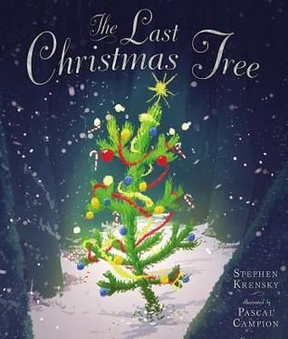
Age Level: Pre-K
Subject(s) Area: Language Arts
Materials Needed:
- “The Last Christmas Tree” by Stephen Krensky
- Plain paper
- Markers and/or crayon
Standards: (K-3 or Pre-K Content Standard OR Early Learning Guidelines)
- LL.1.1 Recall and retell information from a book with attention to the main events or major ideas
- SED.1.3 Show increasingly ability to regulate and communicate own feelings and emotions
Objectives: Students will:
- Students will listen intently to story while pulling out their favorite main ideas
- Students will ask questions if any form during story
- Students will draw a picture of their own main idea of the story
Learning Activities:
- Teacher will read book
- Teacher will help gear what some of the main ideas in the book was
- Teacher will go over what main ideas/main events are
- Teacher will ask students what some of their favorite parts of the story was – and build it into how it fits into the main ideas
- Explain who the illustrator is
- Students are to draw their favorite main idea from the book – and make their own illustration of their favorite part
Reflective Questions:
- “How did the little Christmas tree show that he was excited?”
- “Whose house did the little Christmas tree end up at?”
- “What were the cues to tell you that?”
- “Did the illustrator – the person drawing the pictures – help tell the story in their own way?”
Vocabulary Words:
- Bursting – in book
- Main Ideas
- Main Events
- Illustrator/Illustrations
Assessment:
Informal:
- Students are able to listen to story
- Students are able to verbally share their favorite part of the story
- Students are able to answer questions about what are some important parts to the story
Formal:
- Student’s drawing/illustration matches some main ideas to the story

Reflection:
- With this student I worked one-on-one with him because Mrs. Lacey said that he needed some practice with teacher-child lessons
- This little boy is very to himself – when it comes to students and teachers – he has a hard time talking to anyone – like in his own world ALL the time
- So for this book read – I pulled him over to the reading center and read to him alone
- Another little girl from the class decided to come join us too – she is three so pretty young to understand what Mrs. Lacey meant when she said I would be working with the boy and no one should bother us
- But the little girl coming along was okay – it allowed me to see the social interaction for this little boy and girl
- So I read to the both boy and girl the story – asking some reflective questions during the story
- The boy was very actively engaged! I was completely surprised – Mrs. Lacey was saying he was having a good day that day
- He responded to my questions and reading very interactively
- We then went over to the art tables and told him about his favorite parts of the story
- Then moving into the illustrations telling us some main parts to the story
- He merely grabbed the idea of his favorite part of the story
- So he ended up drawing a picture of Santa Clause picking the little Christmas tree – which was in favor one of the main ideas of the story

