McKayla Roll
Professional Dress
HSL 110 03
November 21, 2013

1. Acceptable professional dress.

2. Professional work attire for your future career….. Good outfit for an elementary teacher
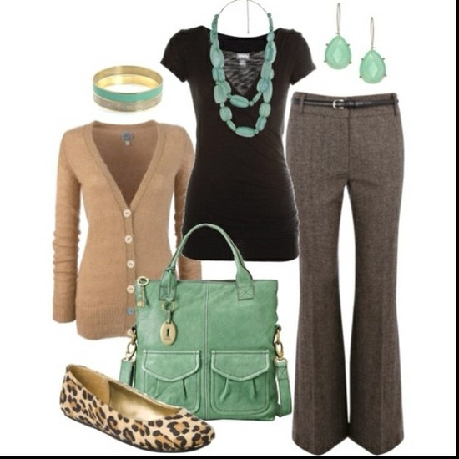

3. An example of unprofessional dress and tell why you think this illustrates a poor professional image.

*** This illustrates poor professional dress because the skirt comes up to high. It should be all the way to the knee or a little bit above the knee.

4. What is one thing you learned today about professional dress that you know will help you in the future?

I learned today that we could where slips with some dresses

I also learned that colored nail polish is counted as an accessory; and we should only wear up to seven accessories.

