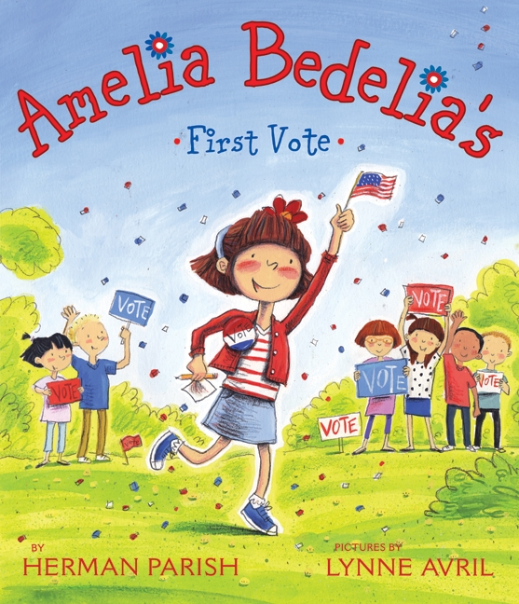
“Ameila Bedelia’s First Vote”

Grade Level: 3rd grade

Subject(s) Area: Social Studies (also association of mathematics)

Materials Needed:
- “Amelia Bedelia’s First Vote” by Herman Parish
- Basic Government Vocab cards (attached)
- White board to create bar graph
- Quiz on basic vocab words and voting processes (I created myself)

Standards:
- North Dakota Standard Four: Government and Citizenship
~ Citizenship 1.4.1 Applying good citizenship

Objectives:
Teacher Guide | Student Guide | Modification (Students with Disabilities)
- As a teacher I will learn better as I perform this lesson how different students will react in the voting procedure.  - I will also be able to learn how students will take to studying vocab words by playing a game. | - By teaching about basic government vocab words and reenacting the voting procedure, it will prepare the students to become a more informed citizen.  - The students will be using Bloom’s Taxonomy levels: Remembering (studying the vocab words), Understanding (taking the quiz at the end), and Applying (apply the voting procedure to the real world as they perform a fake process). | - I want these children to still partake in the reenactment of the voting procedure and allow them to get whatever skills they form out of that.  - I, also, wish that when taking the quiz they will be able to relate to the matching vocab game we played and the voting procedure we did in class.

Learning Activities:
Teacher Guide | Student Guide | Modification (Students with Disabilities)
- Read “Amelia Bedelia’s First Vote”  - Hand out vocab papers and go over the vocab words to help them better understand  - Take any questions the students have about any words  - Teach the students the rules to the matching game  - Pair up students and allow them to play vocab game in their groups  - Get class together again  - Go over what laws are, and how they come into effect  - Have class bring forth ideas that could be put on the ballot to vote on  - Narrow down list and make out a pretend ballot for the students to vote on  - Hand out individual ballots to each student and allow them to make a vote  - Talley up the votes  - Graph a bar graph on the board to show results on what got voted on  - Allow the class to draw a conclusion using the bar graph | - Read “Ameila Bedelia’s First Vote”  - Give students basic government vocab cards  - Play matching game with partners on those vocab terms to better understand them  - As a class, come up with class laws that we want to go into a ballot  - Do a private individual ballot for each student  - To represent class results, make a bar graph and use that to draw a conclusion on the winning ballot | - Allow the student to go along with each student guide steps  - Make a few modifications in the matching game to allow better understanding (example: with each vocab word have a picture to demonstrate the definition also)  - Allow the student to interact with the voting process and let the student come up with one law that will be placed on the ballot  - In the individual ballot voting, I might have to read the choices to him/her

Assessment:
- Getting the students excited to learn the government by allowing them to partake in their own mock voting procedure
- After going over in class, playing matching game on the vocab words, actually carrying a voting producer, and going over the results in a bar graph assess the students by giving them a quiz on the vocab words and process of voting

Reflection:
- What did I do well?
- If I were to teach this lesson again, what would I keep the same?
- If I were to teach this lesson again, what would I change?
- This is completed after your lesson is taught.

