1.Title / Content Area: | First Graders will inquire knowledge of map skills (cardinal directions, map skills, symbols) by using Gardner’s Multiple Intelligences through the unit plan. | 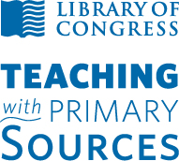
2. Developed by: | McKayla Roll
3. Grade Level: | 1st Grade
4. Essential Question: | How do I inquire process skills to build primary source evidence of map skills?
5. Contextual Paragraph | Standard Reaching: SS.2.1.2 – Apply map skills to read a simple map  Guiding Questions: What is the map intended to convey? What physical features are portrayed? What audience is the map created for?  - Key Terms: Cardinal directions, map skills and symbols  - Assertions: Some guiding claims about symbolization, gaining insights into natural places and visual literacy.  - Similar Concepts: design, plan, diagram, projection and outline

Annotated Resource Set (ARS)
Phase I

6. Resource Set
A Map of the World with Ships DUKE & DUTCHESS | Map making, Interior Dept. printing presses | VIEW OF COMPASS ROSE TILE INLAY IN FLOOR OF LOBBY | Avery Island Sugarhouse, Avery Island, Iberia Parish, LA | Map of the battle field of Gettysburg | Madison Building Sixth Floor
This resource will help illustrate to students on map recognition. Students will use this resource during science curriculum connection lesson. | Between 1918 and 1928, photo of Library of Congress Prints and Photographs Division identifying map making.  Students using visual/spatial under knowledge in Bloom’s Taxonomy. | In Long Beach, California the Roosevelt Base, Administration, and Brig Building has a compass rose pointing in a southeast direction. | This resource will guide students towards considering the aspects of island maps. Map has key, landform features, brief description and year of publication. Students will create in art curriculum connection lesson. | July 1st, 2nd and 3rd of 1863 took place in Gettysburg, Pennsylvania. The contributor names, Woeltje and Cutting, who used this map to navigate during the battle. This resource helps express to students that map(s) give a larger meaning sometimes. | Map layout using symbols that guide people around Madison Building Sixth Floor. The Madison Building helps make up part of the Library of Congress in Washington D.C. Students are referred to this resource to expand their idea on maps.
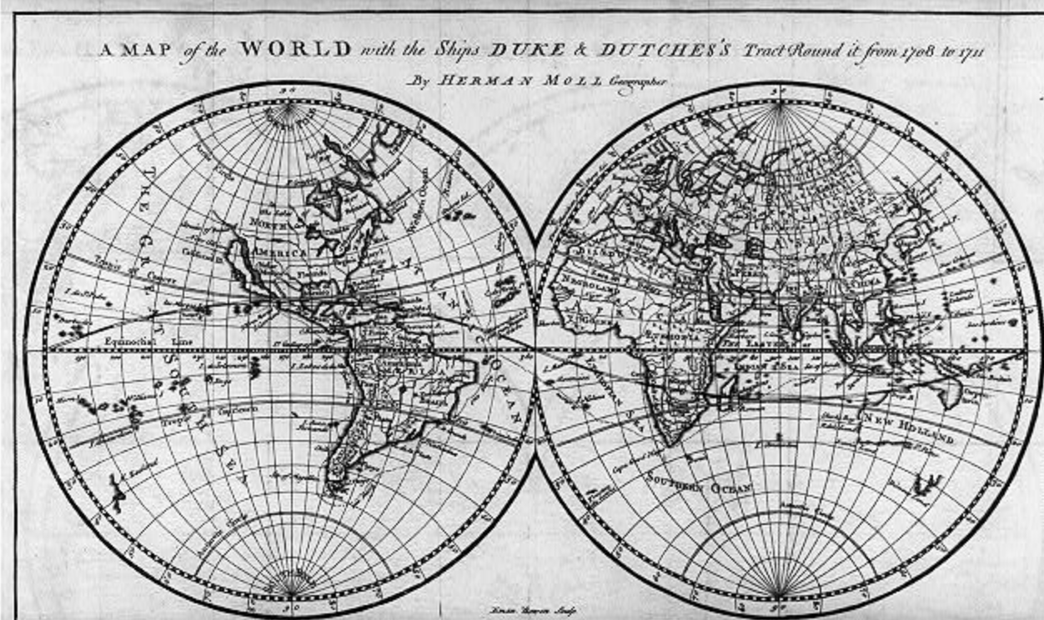 | 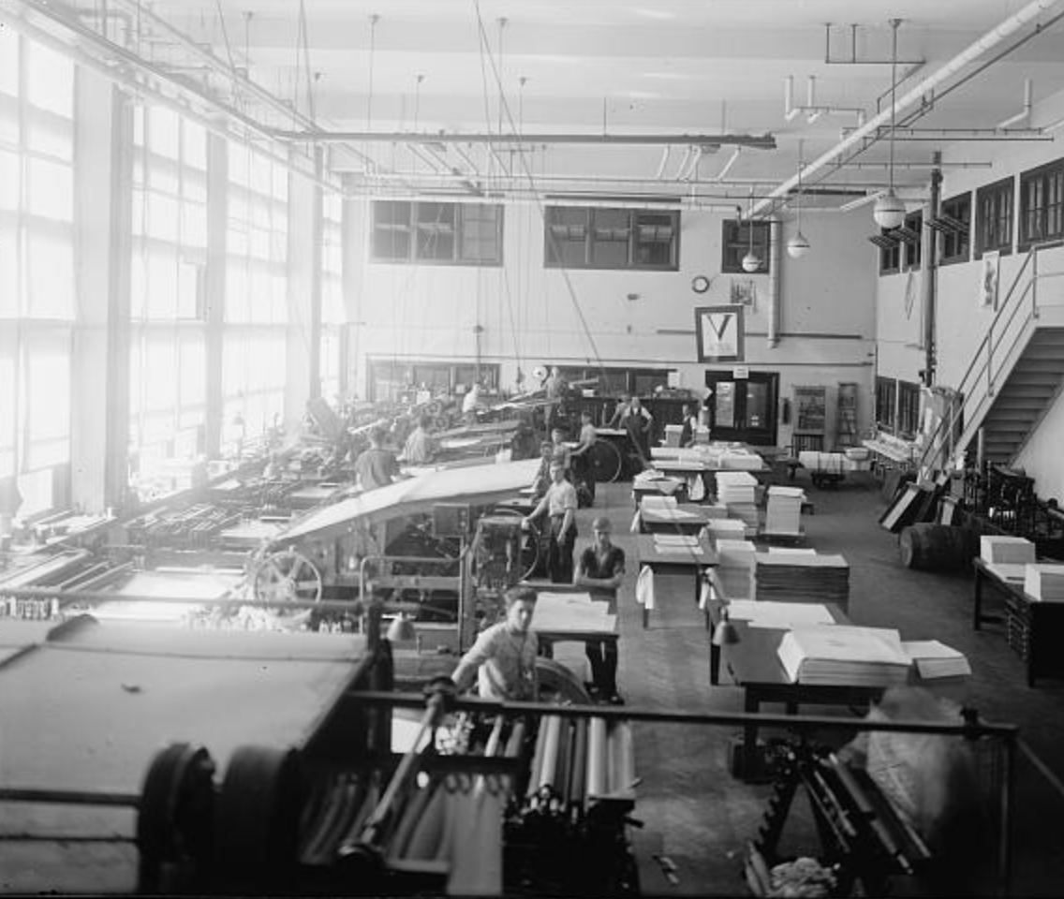 | 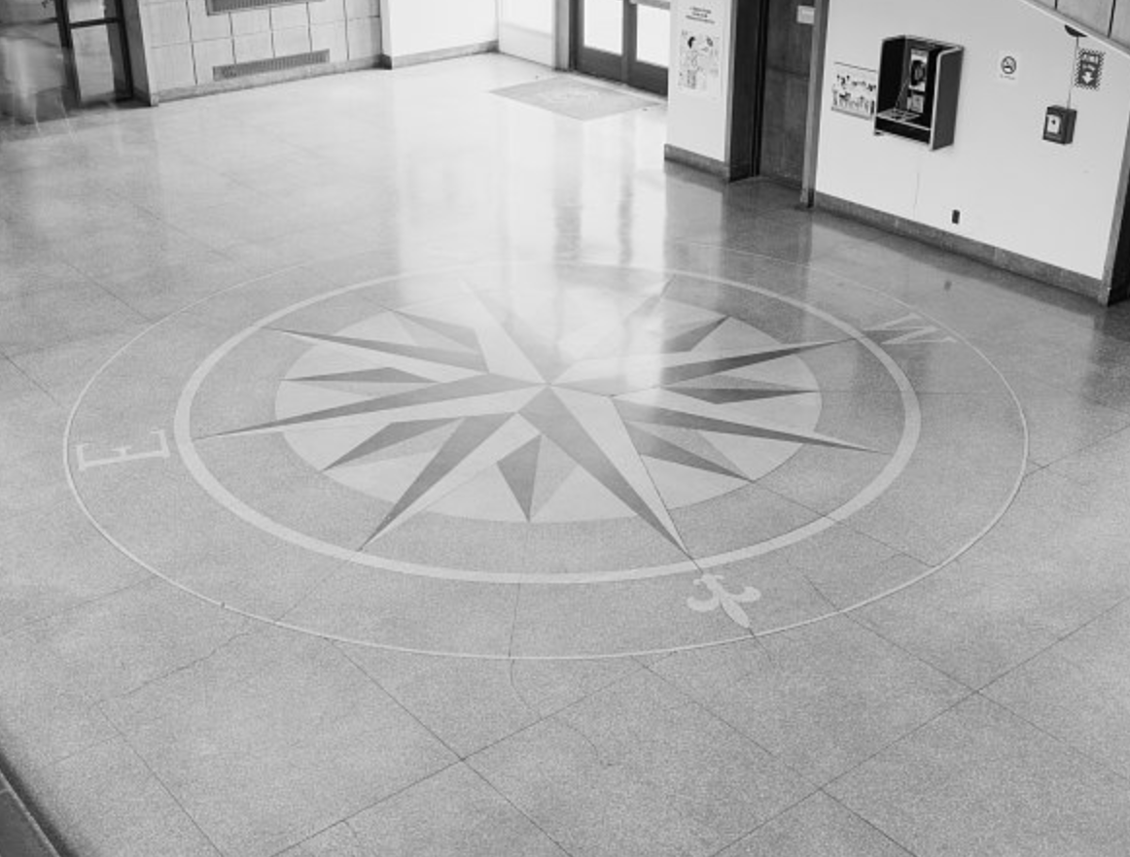 | 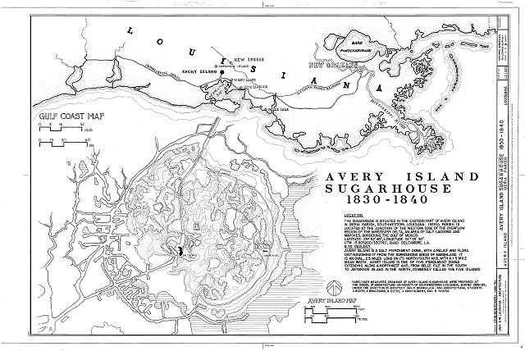 | 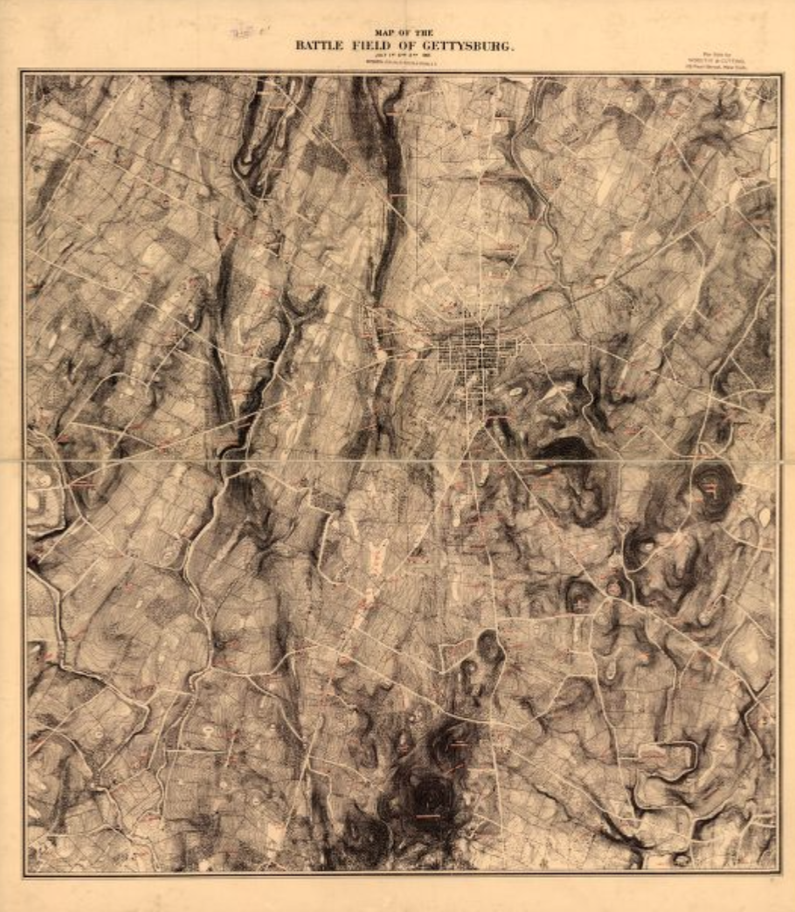 | 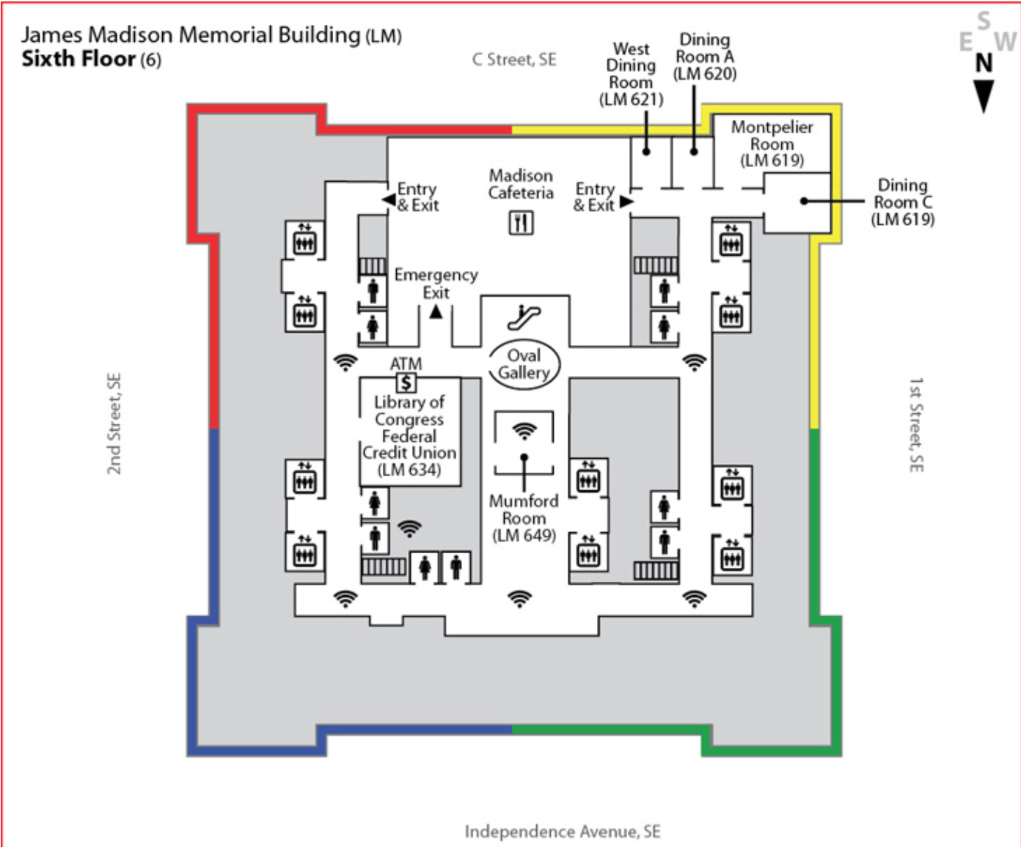
Library of Congress  http://www.loc.gov/pictures/resource/cph.3b09732/ | Library of Congress  http://www.loc.gov/pictures/item/npc2008013949/ | Library of Congress  http://www.loc.gov/pictures/item/ca2439.photos.325399p/ | Library of Congress  http://www.loc.gov/pictures/item/la0462.sheet.00001a/ | Library of Congress  http://www.loc.gov/item/99448798/ | http://www.loc.gov/visit/maps-and-floor-plans/madison-building-sixth-floor

Phase II
Foundations Annotations
7. Curriculum Connections

Science:
Students are producing maps of the world. Materials needed: paper plates, blue paint, crayons, print outs of continents, and pencils. Students are creating a representation of the world by the plate model. Students paint plate blue to resemble water. Use primary source of the classroom globe, teacher’s examples and “A map of the world with ships DUKE & DUTCHESS” to glue the continents in the correct place on the plate. Color and label the continents.
Math:
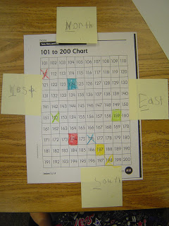
Working with cardinal directions and numbers 1-120. Materials: 1-120 number chart, crayons/markers, sticky notes, and pencils. Students each get copy of number chart and four sticky notes. Teacher walks through labeling sticky notes North, South, East and West. Students place North on top of paper, south on bottom, west to left, and east to the right. Teacher calls out “Find the number that is 2 boxes down and 4 to the west.” Students then proceed to color that box.
Language Arts:
Students use resource “VIEW OF COMPASS ROSE TILE INLAY IN FLOOR OF LOBBY” to write a narrative about how they used the compass rose as a guide to find a lost location.
Art:
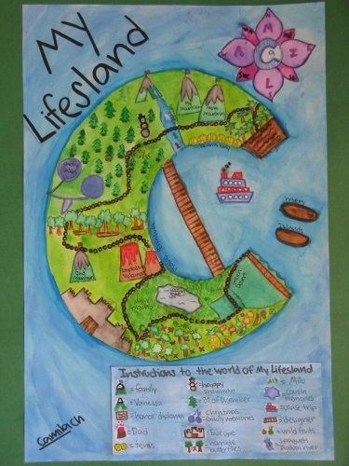
“My Island” art activity. After viewing resource “Avery Island Sugarhouse, Avery Island, Iberia Parish, LA”, students will use Bloom’s Taxonomy of applying knowledge to produce and draw their own island. Materials: plain paper, crayons, markers, oil pastels, colors pencils and pencils. Students will create an island of personality. Students will also be taught what a map key is for and implement that into their island of personality.
Social Studies:
“Where in the World” mapping skills booklet. Found on Teachers Pay Teacher - https://www.teacherspayteachers.com/Product/Where-in-the-World-A-free-mini-geography-unit-for-first-grade-1185204.

8. Curriculum Standards

Science:
1.1.1 - Identify models that represent real objects (e.g., globe represents the Earth, doll represents a real baby and etc.)
Math:
1.NBT.1 - Count to 120, starting at any number less than 120. In this range, read and write numerals and represent a number of objects with a written numeral
Language Arts:
W.3 - Write narratives in which they recount two or more appropriately sequenced events, include some details regarding what happened, use temporal words to signal event order, and provide some sense of closure
Art:
4.2.2 - Know how expressive images cause different responses and communicate ideas
Social Studies:
SS.2.1.2 – Apply map skills to read a simple map

9. Content & Thinking Objectives

- Science – Students will create a model that will represent the earth.
- Math – Students will get exposed to numbers 1 – 120.
  - During this lesson, students will also get exposed to Cardinal Directions.
- Language Arts – Students will use Bloom’s Taxonomy of Applying to take apart “VIEW OF COMPASS ROSE TILE INLAY IN FLOOR OF LOBBY” to write a narrative about how they used the compass rose as a guide to find a lost location.
- Art – Students will know how to express personalities to create a visual island map.
  - During this lesson, students will also get exposed to map keys.
- Social Studies – Students will discover map skills of cardinal directions, map keys, compass roses, and symbols to discover the world of reading a map

10. Inquiry Activities & Strategies

- Bloom’s Taxonomy – knowledge, application, and creating
- Gardner’s Multiple Intelligences – linguistic, spatial, logical, interpersonal, intrapersonal, naturalist, and kinesthetic
- Other Teaching Strategies Used – inquiry, discovery, collaborating, brain storming, interactive and direct instruction

11. Assessment Strategies

- Social Studies “Where in the World” booklet
- Using a map key in the art lesson of creating a personalized island
- Rubric based on two or more appropriately sequenced events, include some details regarding what happened, use temporal words to signal event order, and provide some sense of closure, that goes along with the narrative writing
- The North, South, East and West game on math. Using the 1 – 120 card worksheet as an assessment of knowing their cardinal directions
- Science creating a model of the earth plate activity
- Different assessments used throughout unit also – observing, actively participating, collaboration with peers and teacher, and formulates questions

Other Resources
12. Web Resources

- http://www.loc.gov/index.html - Library of Congress
- http://www.dpi.state.nd.us/standard/content.shtm - North Dakota Department of Public Instruction

13. Secondary Sources

- http://education.nationalgeographic.org/multimedia/interactive/maps-tools-adventure-island/
  - FUN interactive game that involves students to gain a better understanding of map skills
- https://www.teacherspayteachers.com/Product/Where-in-the-World-A-free-mini-geography-unit-for-first-grade-1185204
  - Teacher Pay Teacher’s booklet activity

14. Print and Other Media Resources

- “Follow That Map!: A First Book of Mapping Skills” By Scot Ritchie
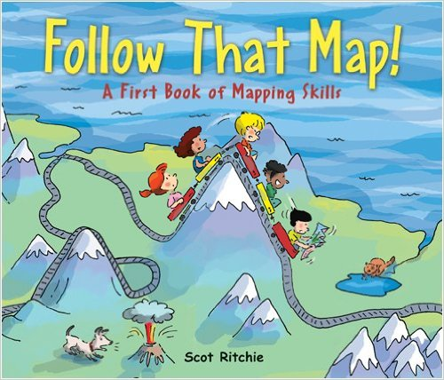

- “Maps and Globes (Reading Rainbow Book)” By Jack Knowlton and Harriet Barton
  - Good history leading up to maps – gives students an extend on the main standard at hand
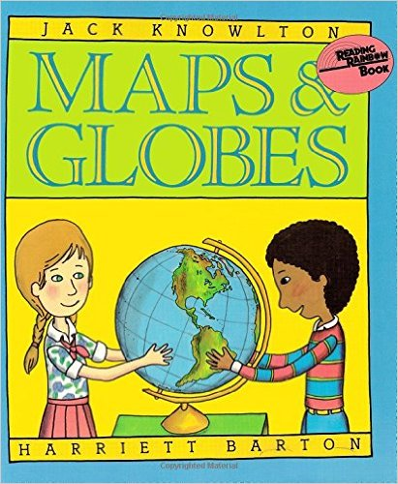

ARS Component Guide
Phase I Components
- Title / Content Area: Provide the title of the ARS. If the title doesn’t explicitly denote the sets theme, please also provide a content area (e.g. Environment, Government, Immigration, War/Military, Women’s History, etc.).
- Developed by: Provide your name and any other contributors to the ARS.
- Grade Level: Provide the grade level(s) for which the set is to be taught.
- Essential Question: Provide an essential question that encompasses the set theme and that could be used as a launching point for use in the classroom.
- Contextual Paragraph for Resource Set: Provide a short paragraph explaining the resource set and describing the context in which the set is to be used
- Resource Set: Provide titles, context, thumbnails and addresses for specific resources. It isn’t necessary to provide a thumbnail for all resources (e.g. audio and video files). Important: Be sure to use a permanent URL and check your hyperlinks for all resources.

Phase II Components
- Curriculum Standards: Provide local, state or national standards that could be addressed through the use of the ARS and subsequent activities

- Curriculum Connections: Provide other curriculum areas to which this set of resources could be applied

- Content & Thinking Objectives: Provide objectives to be met through the use of the ARS and subsequent activities

- Inquiry Activities & Strategies: Provide specific strategies and learning activities which the ARS will be used to support

- Assessment Strategies: Provide assessment methods which will be used to demonstrate student learning after the use of the ARS and subsequent activities

Other Resources
- Secondary Sources: Provide any secondary sources that could be used to supplement the ARS

- Web Resources: Provide links to any additional web resources that could be used to supplement the ARS

- Print and Other Media Resources: Provide other resources that could be used to supplement the ARS

